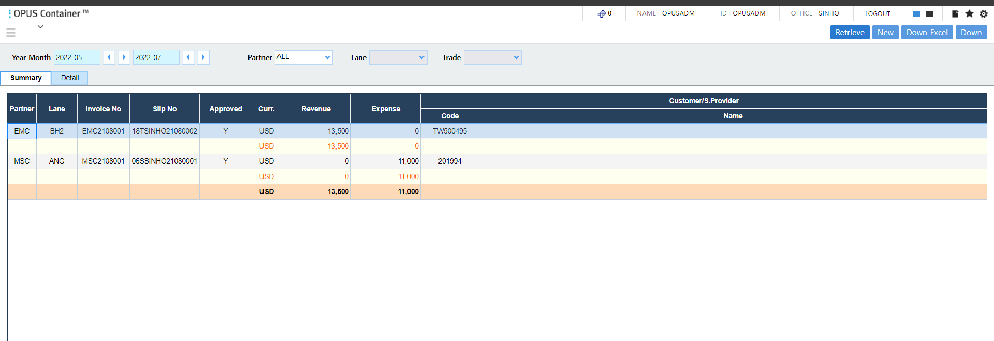

Summary

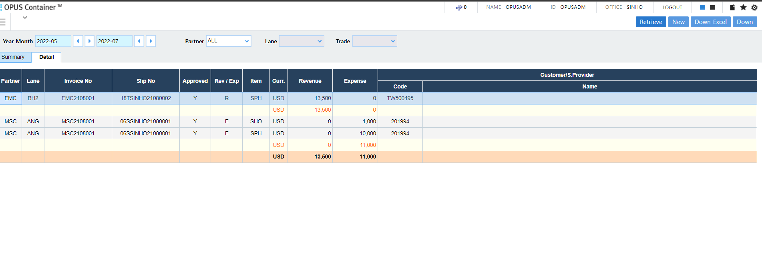

Detail

When double click ROW from Summary change tab detail and select row equivalent

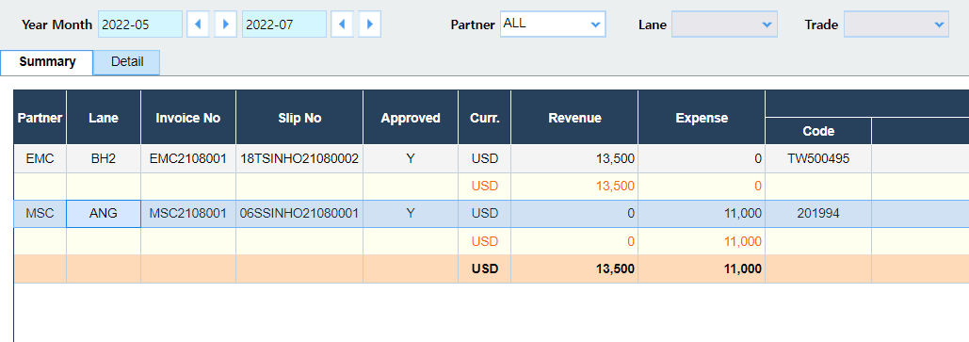

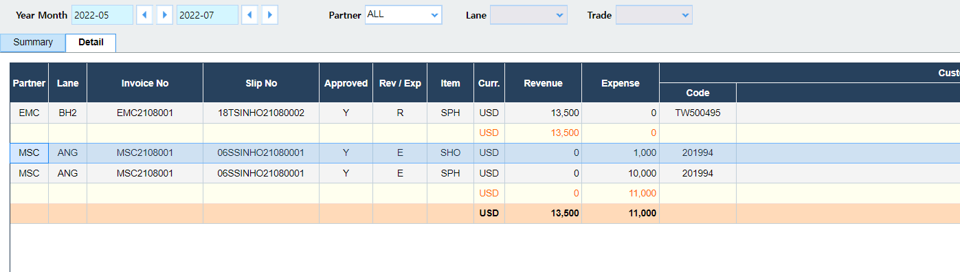

When click change partner Lane enable click

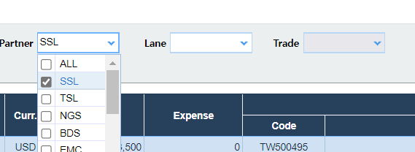

Lane and Trade equivalent

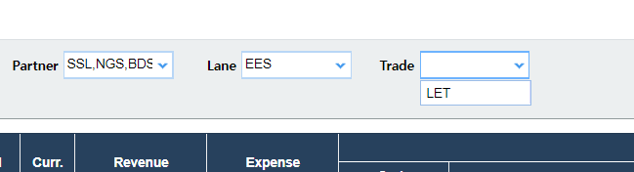

When from Date > To Date

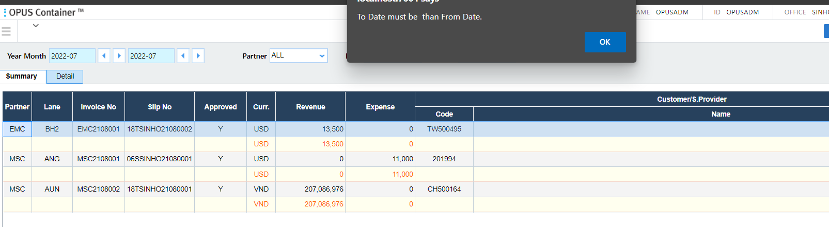

When over than 3 motnh

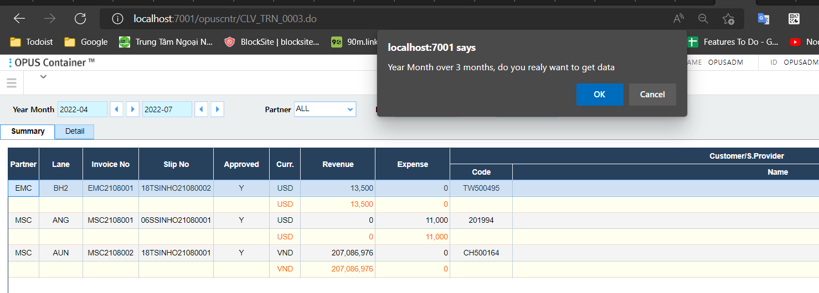

When click New clear data

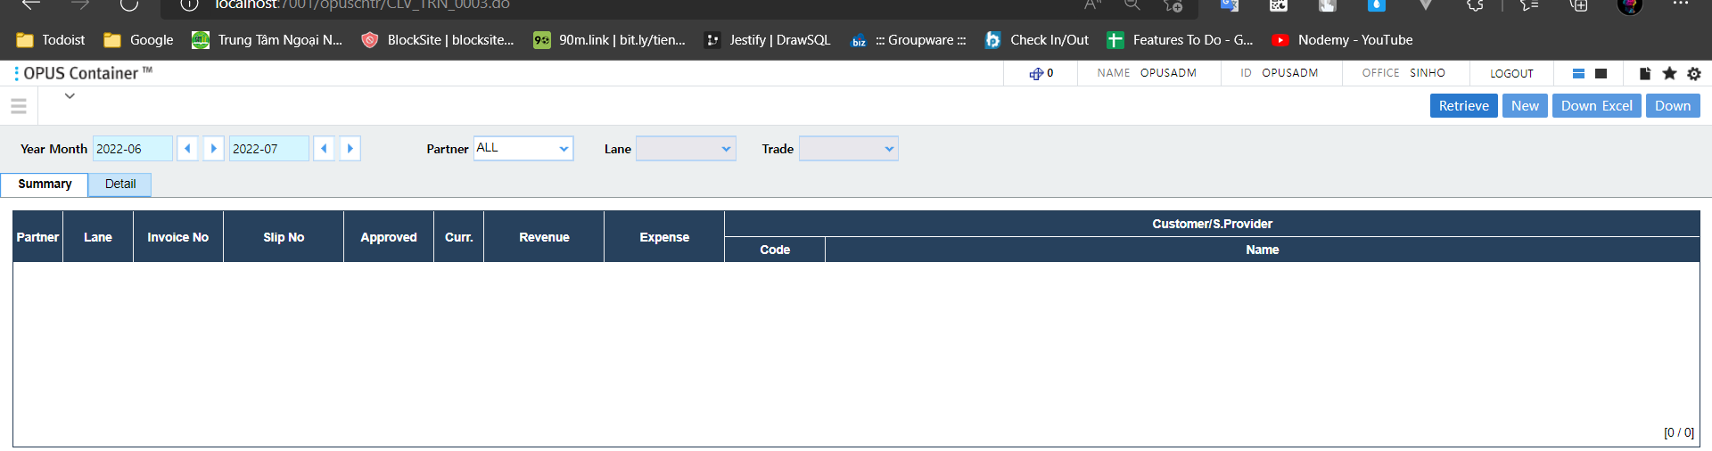

When downExcel down page summary and detail if have data

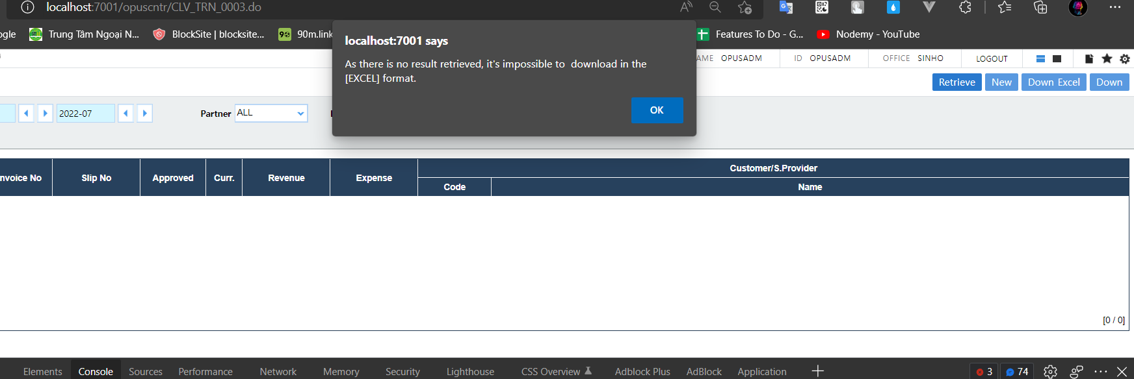

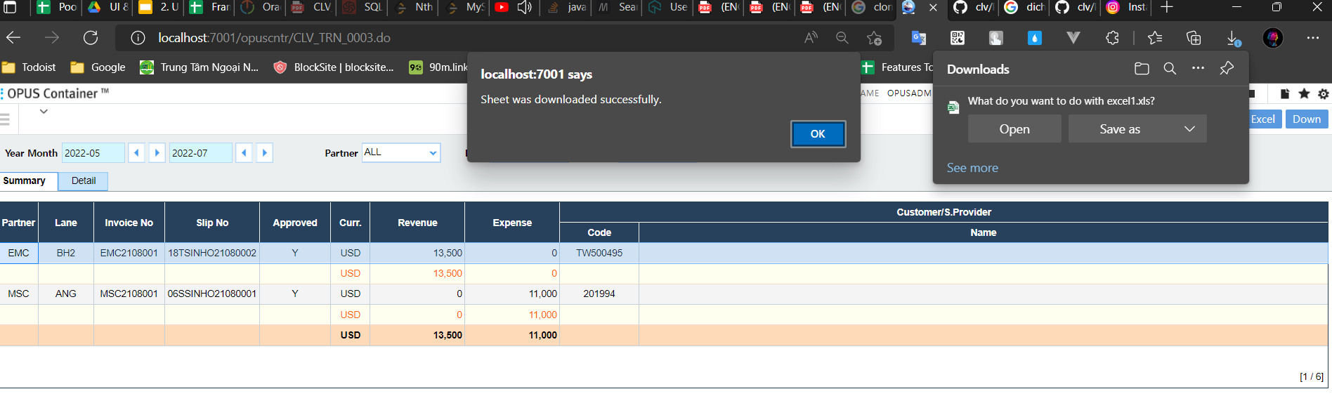

Click down then down excel from server

